Service Exchange Unit Return Guidelines

The cost of a Service Exchange unit includes a deposit to ensure the return of a suitable unit for future use. To qualify for a full refund of this deposit, the following guidance should be noted.
Return Details
The equipment should be returned along with your order and vessel references. A simple table to complete is included as part of this document which will assist fast processing of the return.
Return Date
Cells must be returned within 30 days of dispatch of the outgoing exchange unit. Per exchange terms, credit will be deducted for late return until the core charge is exhausted.
Shipping charges, duties and fees
Cells should be return with terms DDP to the AtZ workshop in the UK. Any fees or duties passed by couriers or customs will be deducted from the service exchange deposit. Returned cells should not be declared as new items with full retail values – we suggest a nominal value of 100USD for customs purposes.
Operating condition
The cell should be functional and read 0ppm when tested with fresh water. Cells requiring significant cleaning or a repair to achieve a 0ppm reading will be liable for workshop labour deducted from the deposit.
Cosmetic condition
The cell serial number should be clearly visible. Tags with defaced, amended or missing markings will require repair.
Anti-tamper seals and stickers should be intact.
Minor wear and tear is acceptable, however bear in mind the good condition in which another customer will expect to receive an exchange unit. Significant corrosion, failure of metallic plating, physical damage to the housing, connectors, fittings or fasteners will mean repairs are chargeable and deducted from the deposit.

Thank you for your assistance – noting the above helps us to maintain a high quality and fast turnaround of your equipment.
Yes Please | Problems to avoid
Customer Return Documents | No Documents or References
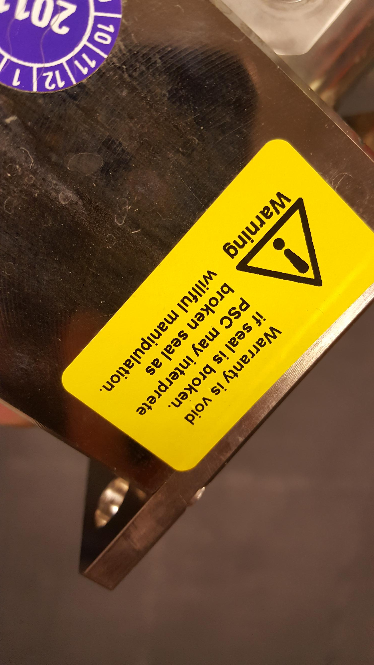  Anti-tamper seals intact | Modified or missing serial number
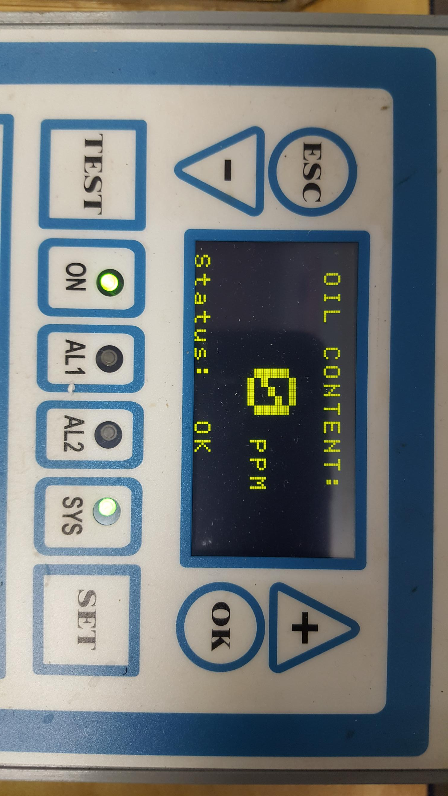  Working condition | 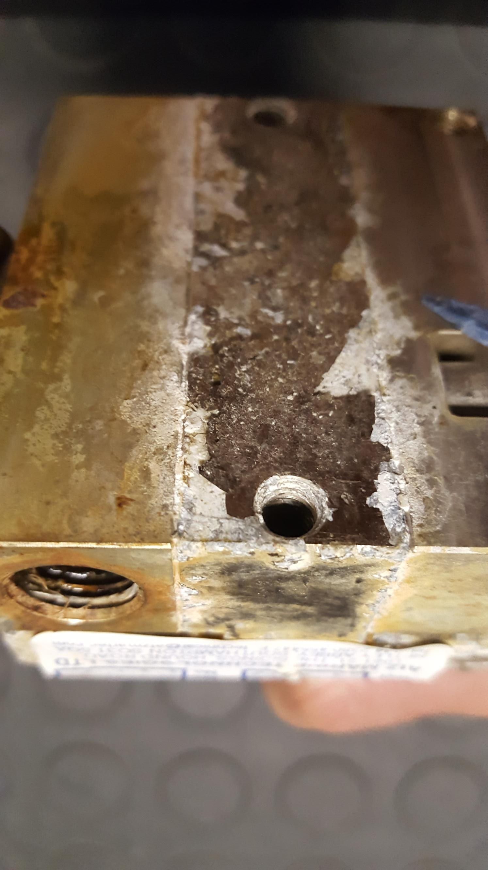  Significant corrosion damage
Well packaged and return within 30 days | 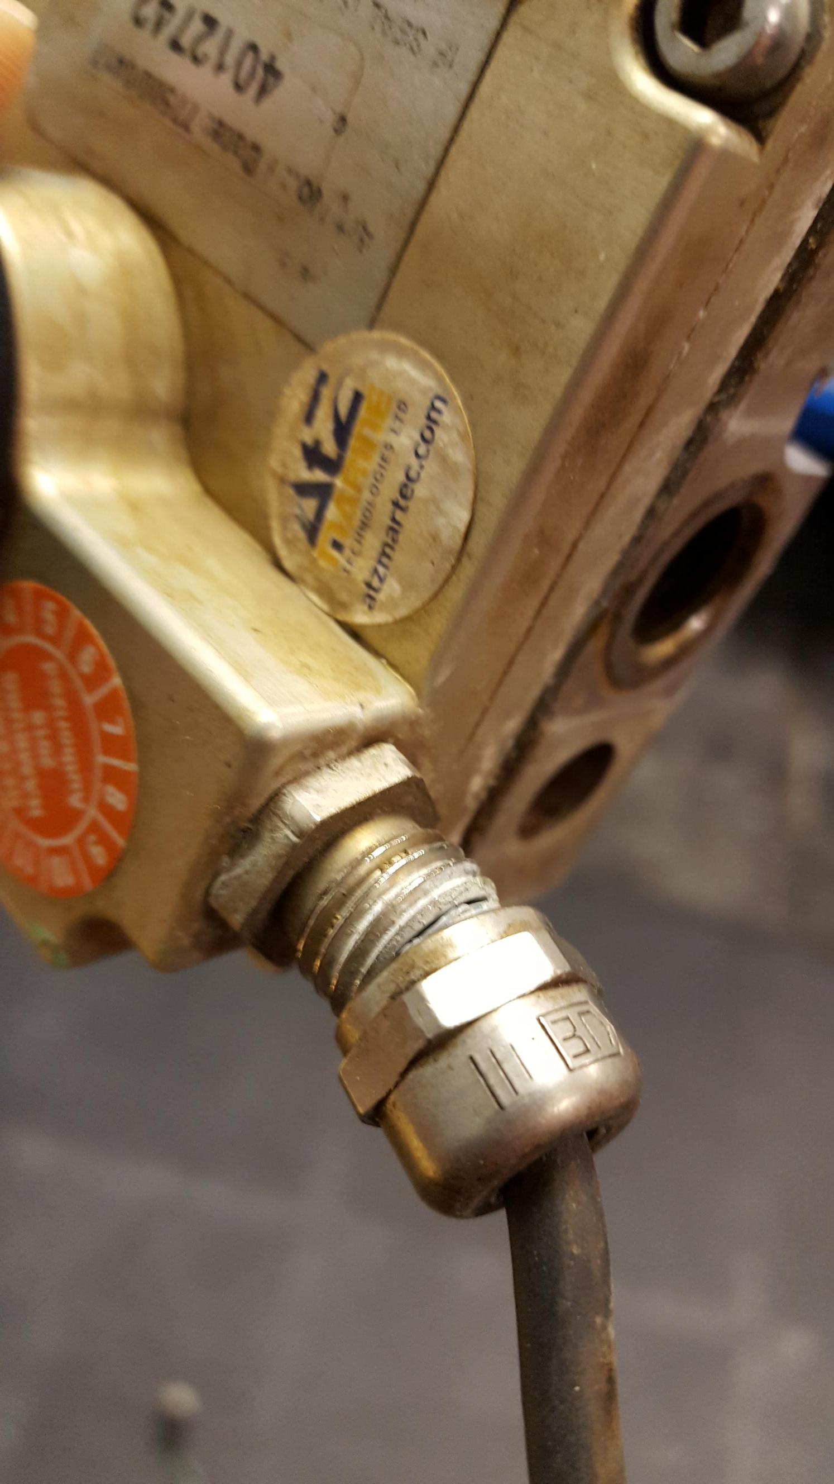  Damaged cables or connectors

AtZ Service Exchange Return Document

Please completion with as much information as possible, and return in the packaging with your unit. If multiple items are sent, please include all device types and serial numbers.

Customer Business Name
Vessel Name
Vessel contact Name
Vessel contact email
or telephone
Purchasing contact name
Purchasing contact email
or telephone
Customer Purchase Order number
AtZ purchase order or quotation number
Equipment Type / Model
Equipment Serial Number
Reason for return (please highlight) | Return for deposit refund?  Return to AtZ held customer stock?  Returning for calibration?  Returning for repair?
Additional notes on a fault or other instructions

Please return equipment to:
AtZ Marine Deckma Service
MIT Queenborough Shipyard
South Street
Queenborough sales@atzmartec.com
Kent ME11 5EE +44 (0) 2380 455447
United Kingdom

